Exposure Visit of Scientist, Students, Farmers at ICFRE-IFP, Ranchi & its sub centre under Normal Extension
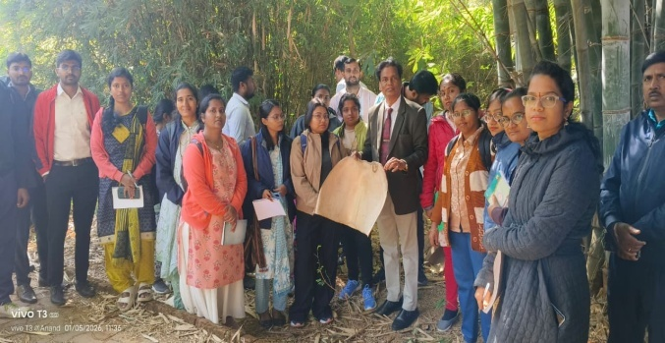 | 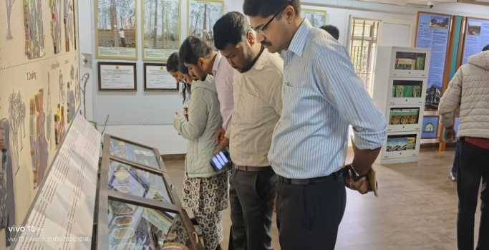
Visit of Newly appointed Scientists of CTRTI, Ranchi & ICAR-RCER-RS, Ranchi
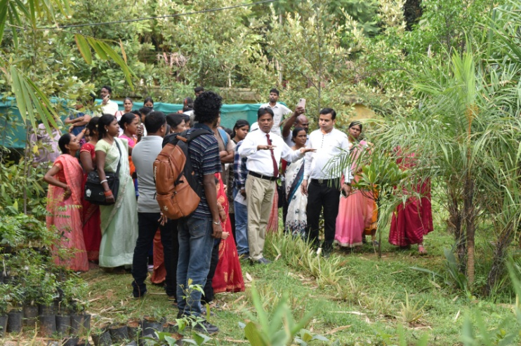 | 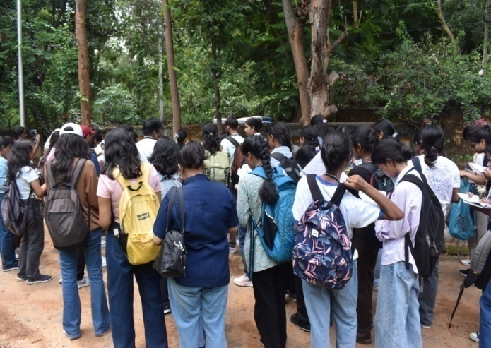
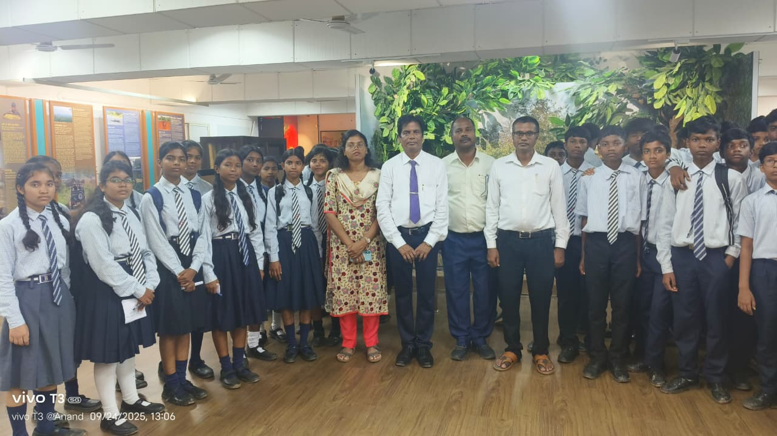 | 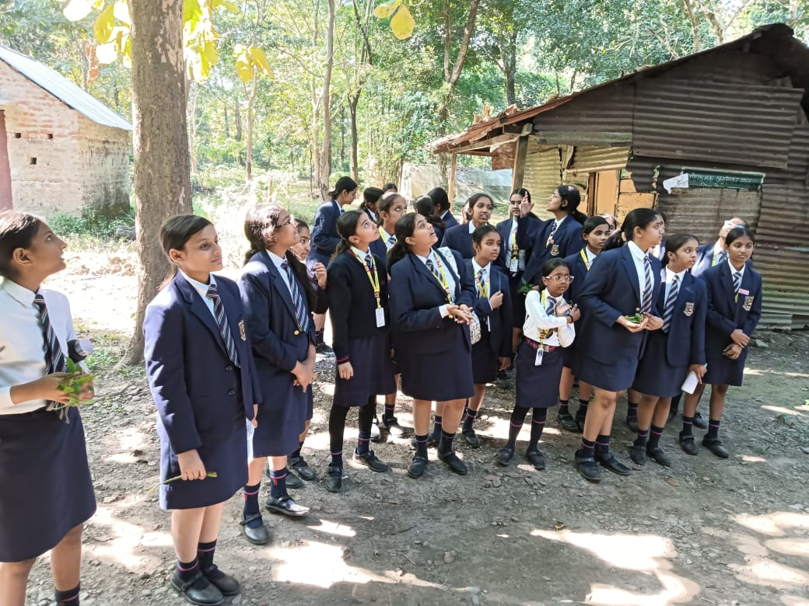
Visit of Students of Different colleges & Schools at ICFRE-IFP, Ranchi & its sub center

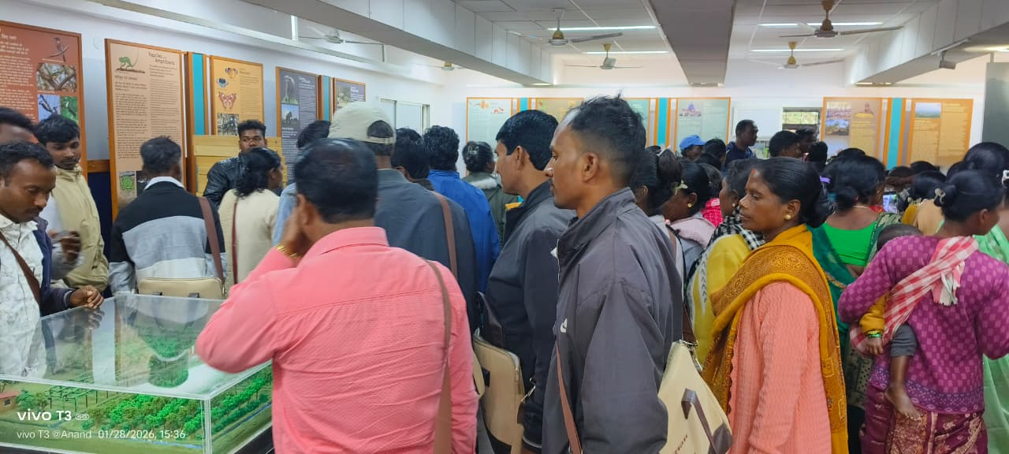 |  | 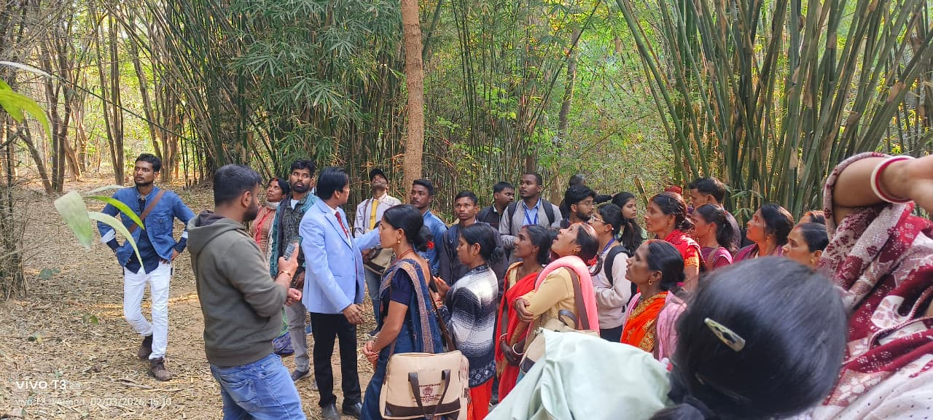
Exposure visit of Farmers of different villages of Jharkhand

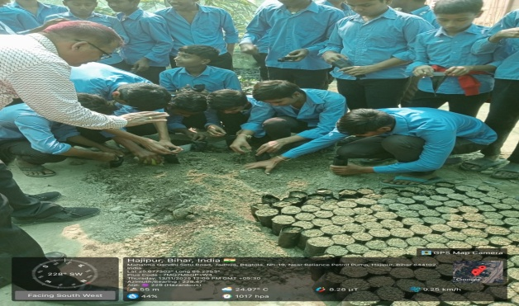 |  | 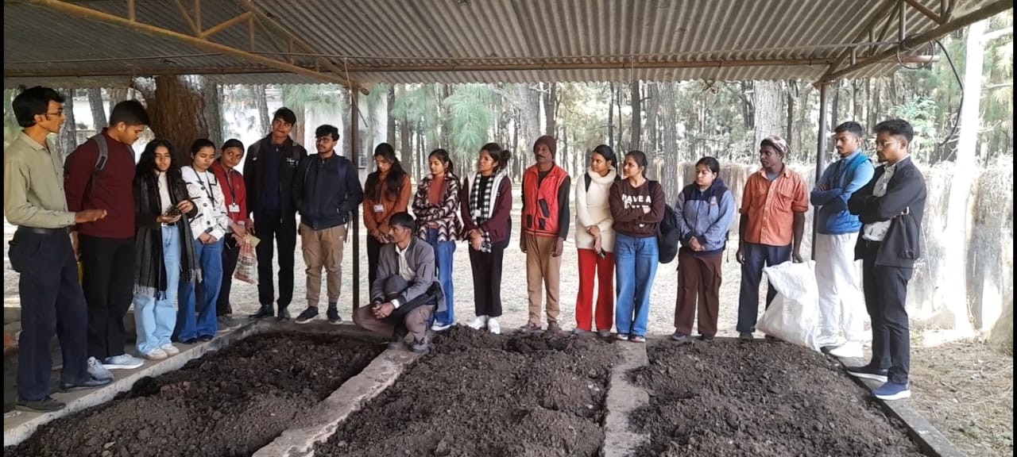
Students visit at Jadua & Mandar sub centre of ICFRE-IFP, Ranchi under Prakriti

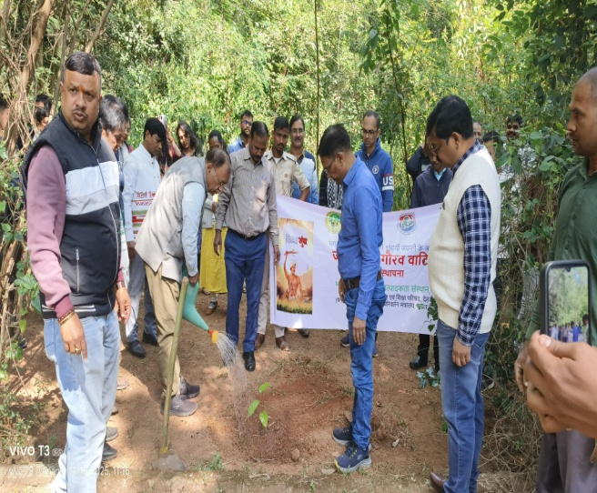 | 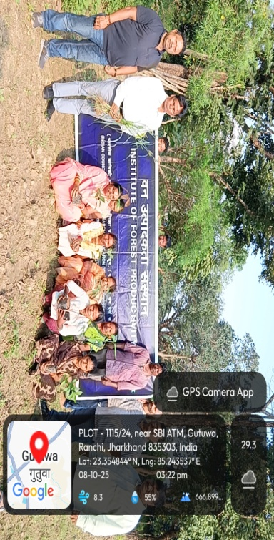
Different program organized by ICFRE-IFP, Ranchi

Students-Scientist Interaction under Prakriti Program
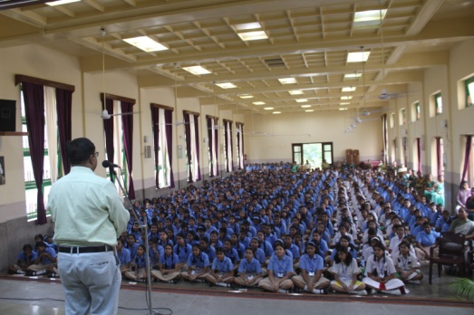 | 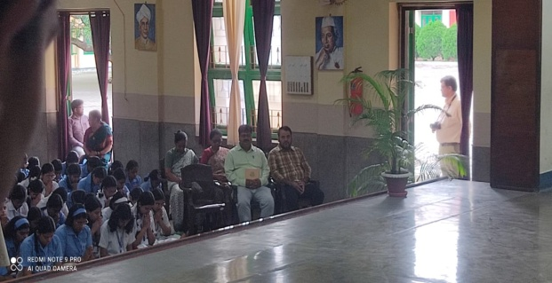
Loretto Academy Ranchi on Dt 30.07.2025

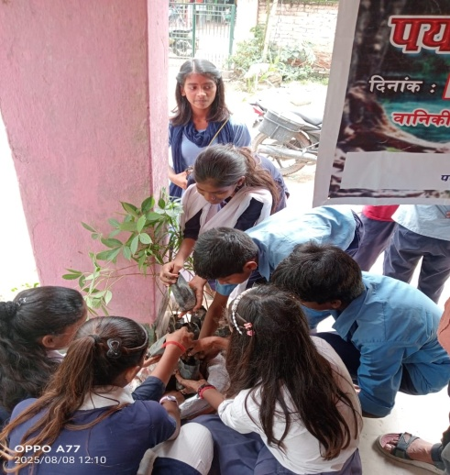 | 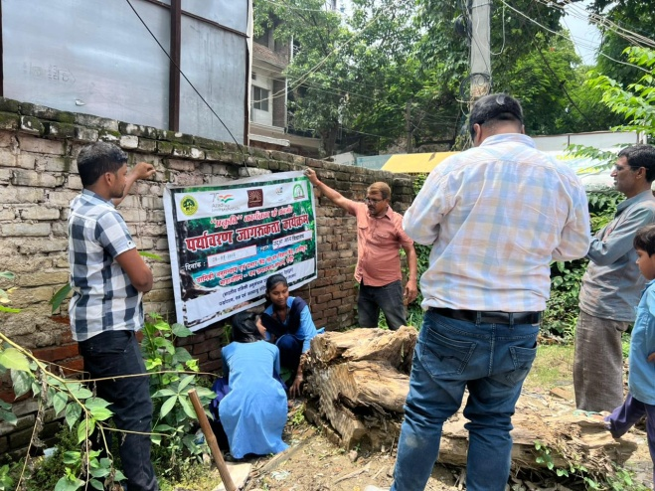
Jadua Middle School, Hajipur on Dt 08.08.2025

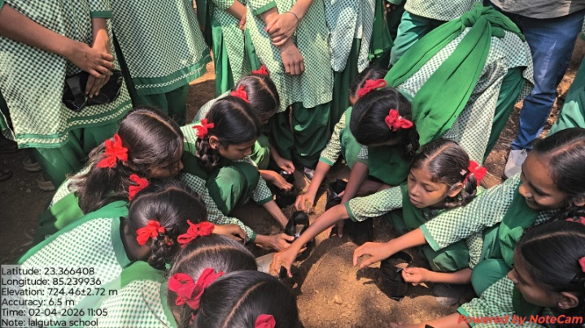 | 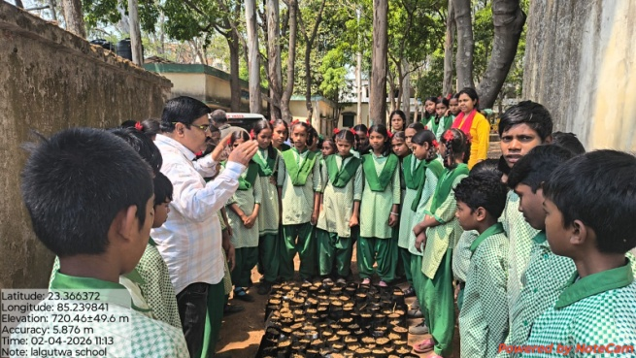
Lalgutuwa Middle School, Ranchi on Dt. 02.04.2026

TREE GROWERS MELA
Organized under the supervision of the ICFRE- Institute of Forest Productivity , Ranchi.
- Sessions on climate resilience and soil conservation
- Participation: tribal farmers, women SHGs, forest officials
- Focus on medicinal & aromatic plants alongside timber and multi-use species. Demonstrations emphasize nursery management, organic pest control and biodiversity-friendly practices.
- Promotion of fruit-bearing & fast-growing species
- Youth and women engagement for income-generating activities
- Village-level demonstration sites for scaling

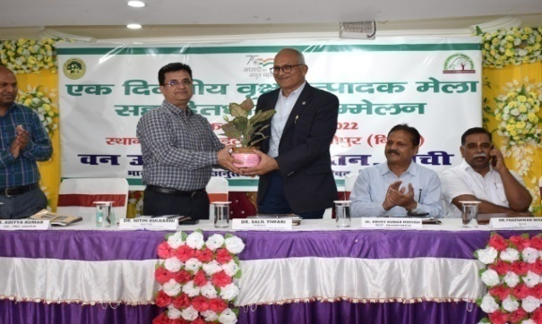 |  | 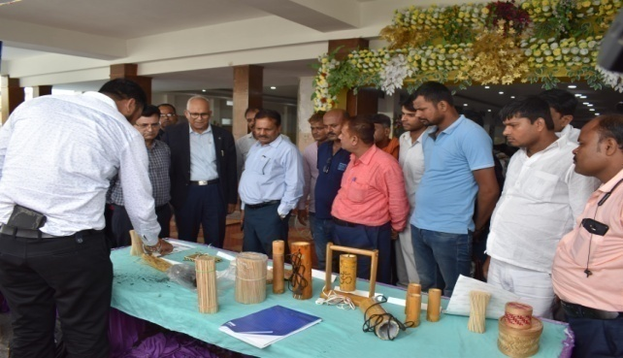
Tree Growers Mela cum stakeholder meet at Hajipur, Bihar on 21st September 2022

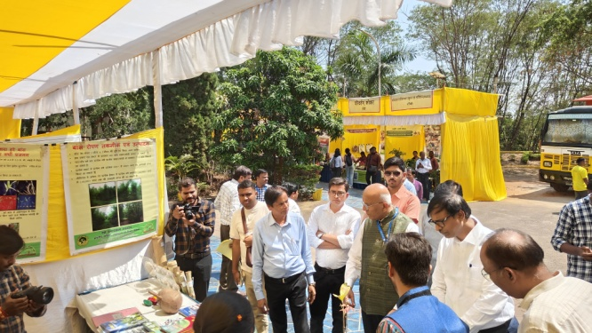 |  | 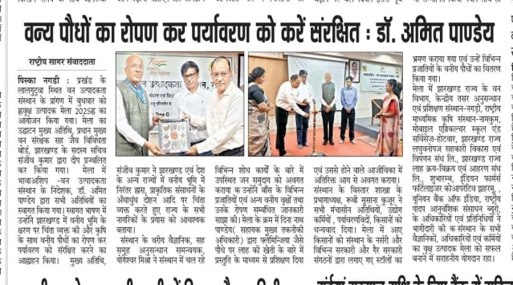
Tree Growers Mela at ICFRE-IFP, Ranchi on 19th March 2025

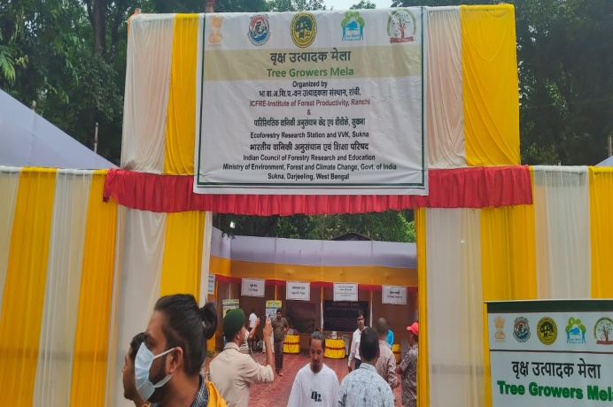 |  | 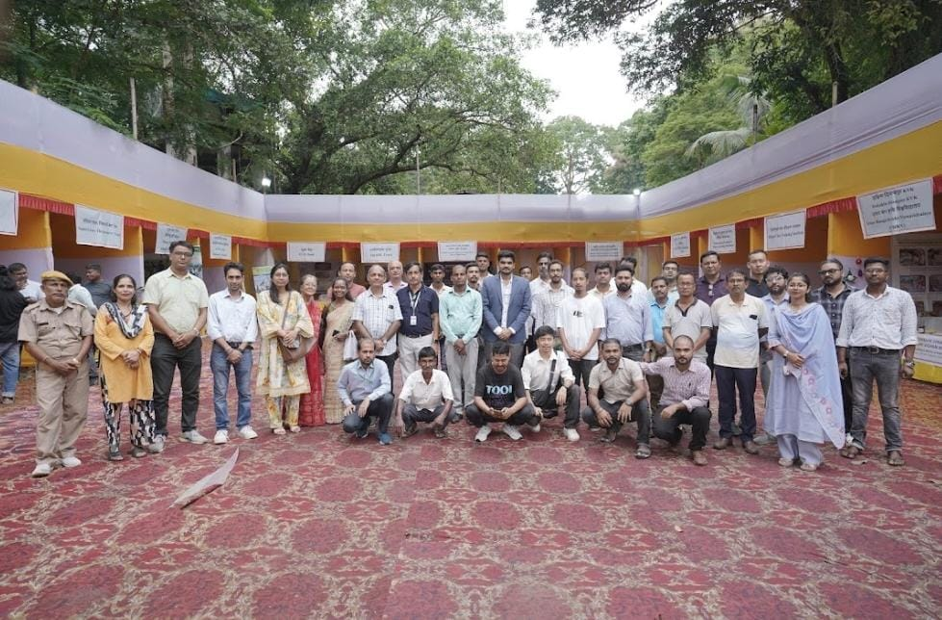
Tree Growers Mela at Sukna, Siliguri, West Begal on 10th September 2025

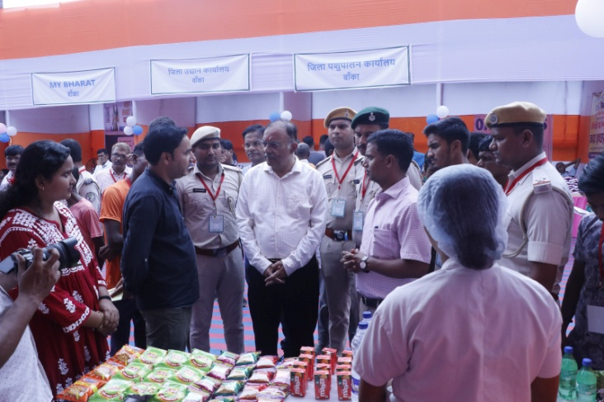 |  | 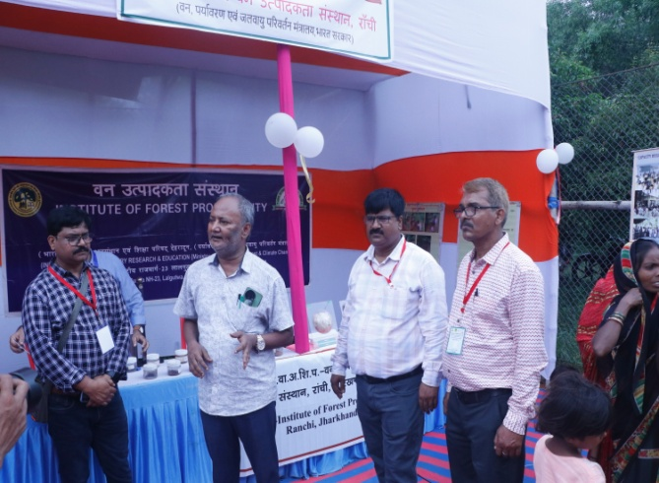
Tree Growers Mela at Supaha, Banka, Bihar on 18th September 2025

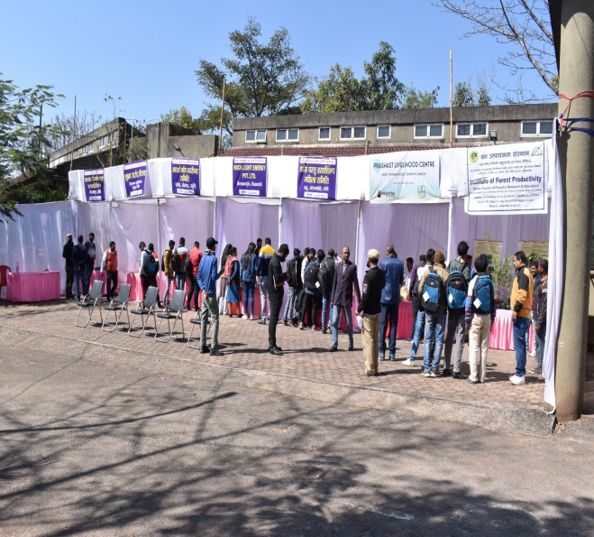 | 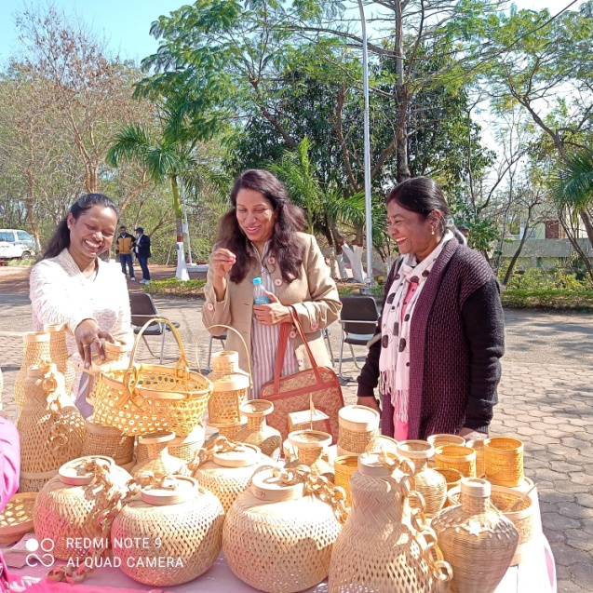
Bamboo Producer cum stakeholder meet under Tree Growers Mela at ICFRE-IFP, Ranchi on 14th February 2022

Van Vigyan Kendra
A network of field centres delivering forestry training and quality planting materials to support sustainable livelihoods and ecological restoration across Jharkhand, Bihar and West Bengal.
Established by ICFRE under CAMPA (MoEF&CC), VVKs aim to bridge the gap between forestry research and field implementation. They translate scientific research into practical, field-ready technologies for ecological restoration, afforestation, and livelihood enhancement. These centers also focus on capacity building, demonstration of improved practices, and promoting sustainable forest-based income opportunities for rural communities.
The major stakeholders include farmers, tribal communities, forest departments, research institutes, and rural youth entrepreneurs. These groups actively participate in training, demonstrations, and implementation of forestry-based livelihood activities.Their collaboration ensures better knowledge transfer, community participation, and long-term sustainability of forest and agroforestry initiatives.
Name of VVK | District & State | Date of Establishment | Location | GPS Coordinates | Facilities Available in VVK
VVK Jadua, Bihar | Hajipur, Patna, Bihar | 20.06.2019 | Hajipur, Patna, Bihar | 25° 40' 37.7796" N  85° 14' 9.5706" E | - 2 story building contains 50 sitting arrangement of One conference hall at VVK, Jadua.  - One Mist chamber & one Hardening chamber with 4 unit each.  - Open Nursery Beds.-
VVK Sukna, Darjeeling, West Bengal | Darjeeling, West Bengal | 26.12.2021 | Sukna, Darjeeling, West Bengal | 26°47´49.0164” N  88°21´40.3842” E | - One conference hall at VVK, Sukna.  - Projector, Projector Screen, Computer, UPS, Printer, Inverter, Signboard, Office Tables, Plastic Chairs.  - Water motor pump for water supply.  - Solar street lights and Solar battery.
VVK, Supaha, Banka (Bihar) | Banka, Bihar | 11.04.2022 | Near Samukhiya More, Amarpur Road, Banka | 24°56'17.7576"N &  86°54'5.3172"E | - 2 story building contains 100 sitting arrangement of One conference hall at VVK, Sukna.  - One Mist chamber & one Hardening chamber.  - Open Nursery Beds.

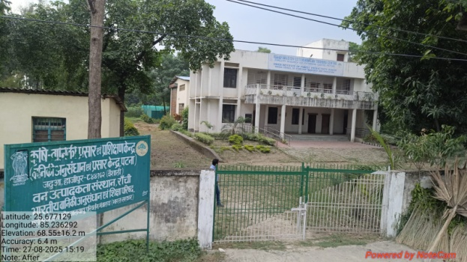 | 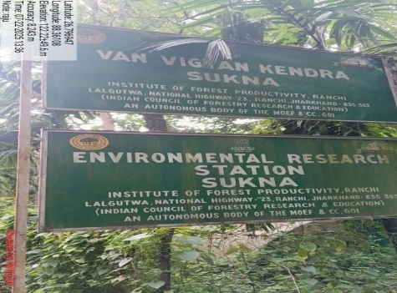 | 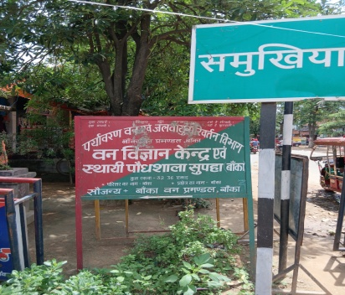
VVK, Jadua, Hajipur, Bihar | VVK, Sukna, Siliguri, W.Bengal | VVK, Supaha, Banka, Bihar

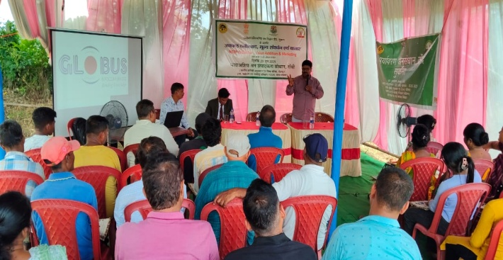 | 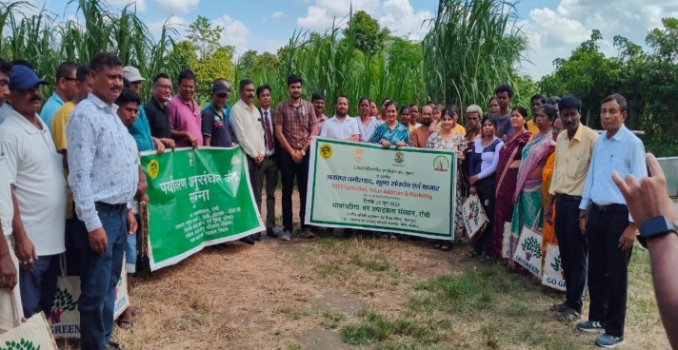
Training program under VVK, Sukna, Siliguri, West Bengal

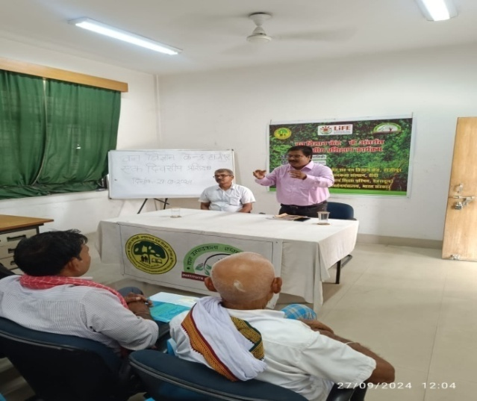 | 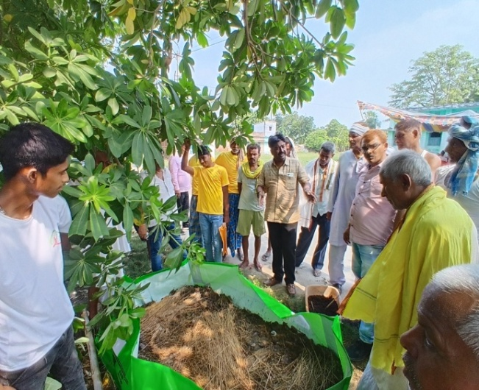
Training program under VVK, Jadua, Hajipur, Bihar

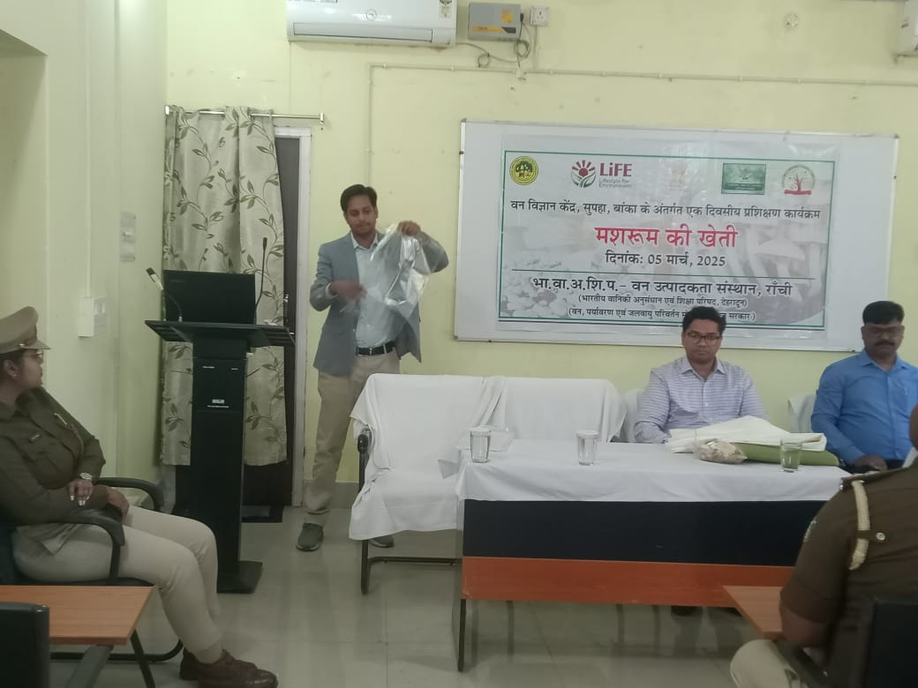 | 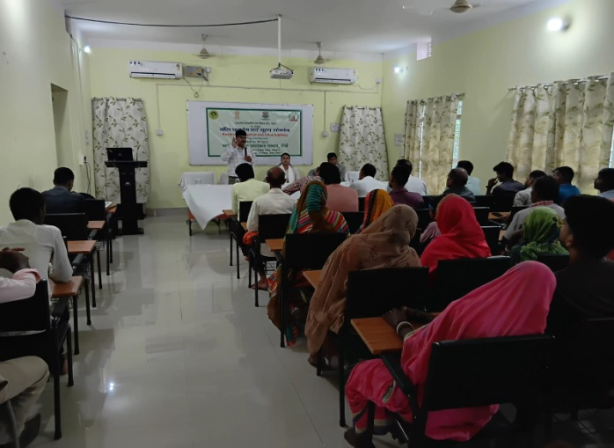
Training program under VVK, Jadua, Hajipur, Bihar
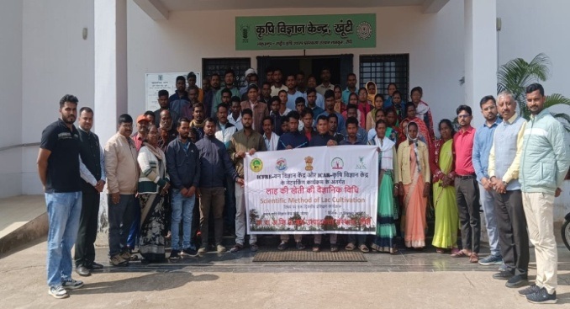 | 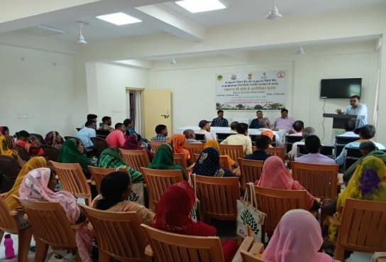
Training program under networking VVK-KVK at KVK, Khunti | Training program under networking VVK-KVK at KVK, Mandu, Ramgarh

Demo Village
The Demo Village concept was initiated by the Indian Council of Forestry Research and Education (ICFRE) to effectively disseminate forestry-based technologies developed by ICFRE and its institutes to end users, particularly farming communities.
At ICFRE-Institute of Forest Productivity (IFP), Ranchi, the Demo Village serves as a model for sustainable rural development rooted in environmentally responsible practices. Implemented in active collaboration with forestry extension programs, it aims to build resilient village communities by enhancing their skills, awareness, and capacity to address challenges related to natural resource depletion, climate change, and environmental sustainability.
The initiative showcases practical, replicable solutions for agroforestry, soil and water conservation, livelihood enhancement, and climate-resilient farming practices—empowering local communities as active stakeholders in sustainable development.
Name of Demo-village | District & State | Date of Establishment | Location | GPS Coordinates | Facilities Available in DV
Kutam, Torpa | Khunti, Jharkhand | 07.09.2021 | Kutam, Torpa | 22°56´38.7846” N  85°12´29.0988” E | N/A
Jidu, Angara, Ranchi | Ranchi | April 2025 | Jidu, Angara, Ranchi on Ranchi Purulia Road | 23° 22' 5.1492"N & 85° 36' 22.2732"E | N/A
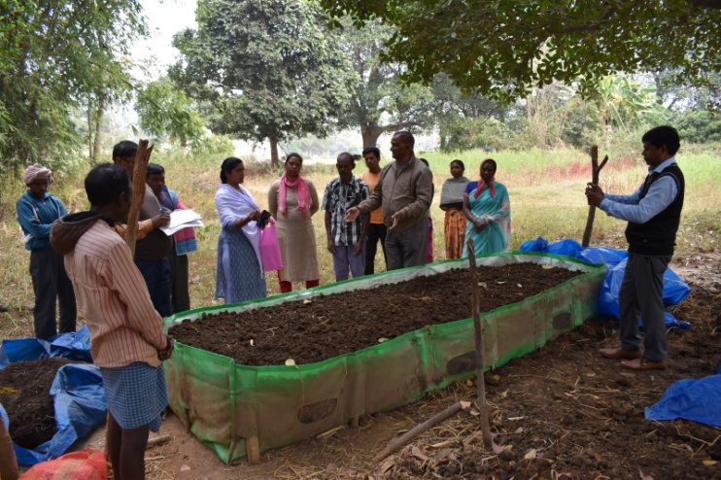  Training on Vermi composting | 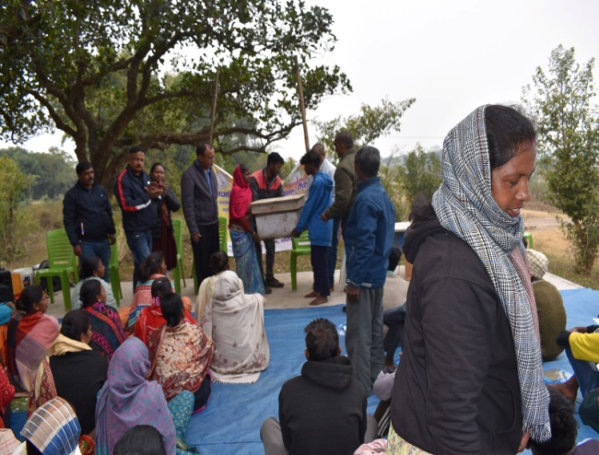  Training on Honey bee
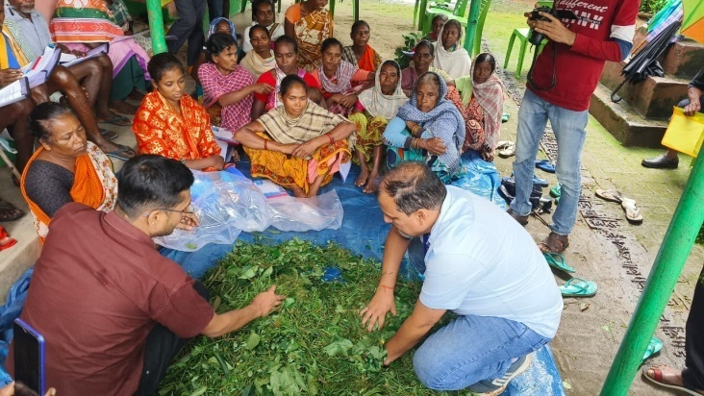  Training on Har Ghar Hara Chara | 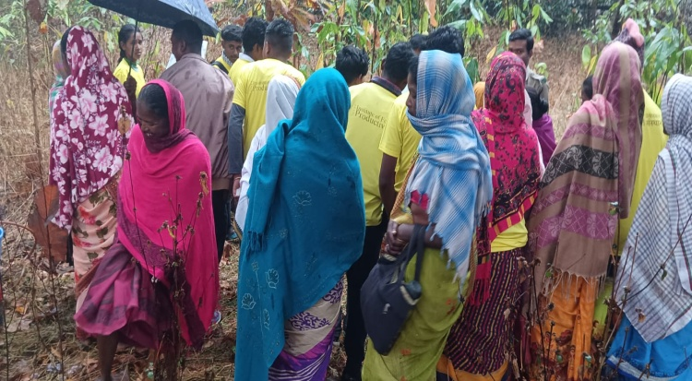  Training on Lac Cultivation on Flemingia
Demo Village Kutam, Khunti
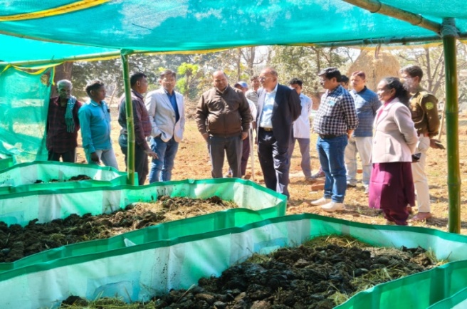  Training on Vermi composting | 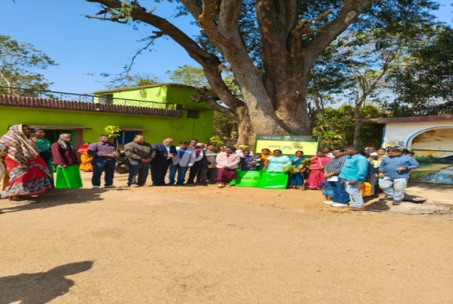  Training on Promotion of Soil Health
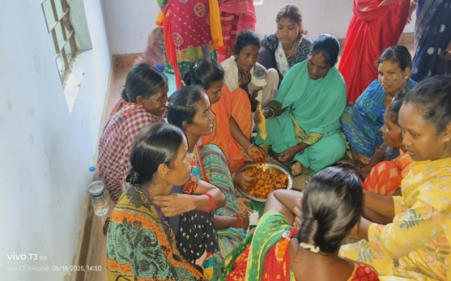  Training on Wild edible Fruit | 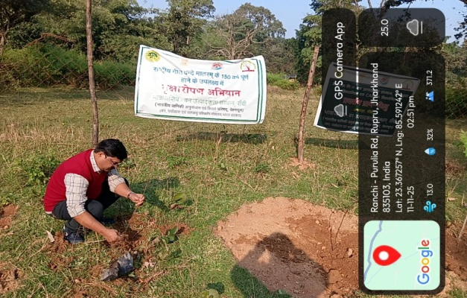  Plantation Program at Demo Plot
Demo Village Jidu, Angara, Ranchi

Success Story of Demo Village Kutam, Torpa
With establishment as Demo village under ICFRE-Institute of Forest Productivity Ranchi, training program runned on Vermi-compost production, Honey collection with distribution of honey box with honey bee, Silage production for their pets throughout the years, Modern technique of lac cultivation etc.
The farmers of Kutam village of oTorpa block previously used chemical fertilizers for their farming. After receiving training in vermi-compost production as a demonstration village under ICFRE-Institute of Forest Productivity Ranchi, the villagers became more aware and took startstart to the practice of vermi-compost production. After preparing vermin-compost, they first used it in their respective fields and found improvement in the quality and quantity of the produce from the fields, along with this the fertility of the soil of the fields also increased.
In this way, farmers started paying more attention to the production of vermi-compost and started earning income by selling the excess vermin-compost to the farmers of nearby village market.

